A PROJECT REPORT
On
UNIVERSITY MANAGEMENT SYSTEM (UMS) USING JAVA
SUBMITTED TO THE DIRECTORATE OF DISTANCE &
CONTINUING EDUCATION IN PARTIAL FULLFILLMENT
OF THE
BACHELORS IN COMPUTER APPLICATIONS
Submitted by
Vrutik Bhatiya (822151451999BCA)
Ketan Senva (822151452025BCA)
Chauhan Divyaraja (822151452000BCA)

Under the Guidance of
Name of Internal Guide
Mr. Jay Pathak
PROJECT REPORT
On
(University Management System (Ums) Using Java)
SUBMITTED TO

Dr. Babasaheb Ambedkar Open University

By

Name: __________________________________________________
Enrollment No: ___________________________________________
Study Centre Name: _______________________________________
Study Centre Code: ________________________________________

CERTIFICATE OF THE GUIDE

Guide Name: Mr. Jay Pathak

Designation: Teacher

This is to certify that the project report entitled “University Management System (Ums) Using Java” has been prepared by Vrutik Bhatiya, Ketan Senva,Chauhan Divyaraja under my supervision and guidance, as a Project work (BCAR-404-PRO). Their Project work is satisfactory

Date: Signature of Guide
ACKNOWLEDGEMENT
It is high privilege for me to express my deep sense of gratitude to those entire faculty Members who helped me in the completion of the project, especially my internal guide Mr. Jay Pathak who was always there at hour of need. My special thanks to all other faculty members, Batch mate & Seniors of S. B. COLLEGE OF COMPUTER APPLICATION & MANAGEMENT for helping me in the completion of project work and its report submission.

DECLARATION
I do hereby declare that this project work entitled “University Management System (Ums) Using Java” submitted by me for the partial fulfilment of the requirement for the second Semester BCAR-404-PRO is a record of my own work. The report embodies the finding based on my study and observation and has not been submitted earlier for the award of any degree or diploma to any Institute or University.

Name:
Vrutik Bhatiya 822151451999BCA
Ketan Senva 822151452025BCA
Date: Chauhan Divyaraja 822151452000BCA

STUDENT’S PROJECT REPORT EVALUATION BY INTERNAL EXAMINER
Date: Year:2024
Program: BCA Semester:4th
Enrollment No: 822151451999BCA 822151452025BCA 822151452000BCA
Study Centre Name: S. B. College of Computer Application & Management - Savli
Study Centre Code: 0791514
Student’s Name: Vrutik Bhatiya, Ketan Senva, Chauhan Divyaraja
SR.NO | PARTICULARS | MARKS OUT OF | MARKS OBTAINED
1 | Project Definition, Its Size, Complexity, and Quantum of Work:
2 | Coding Style Including (I) Generalized Parameterized, (II) Structured-Modular Coding Style, (III) Compactness & Clarity, (IV) Checkpoints for intermediate results, (V) Naming Conventions, (VI) Self-Documented:
3 | Completion and Operational
4 | Quality of Output and Testing Plan, etc.
5 | A Section in Report Containing: Analysis of Various Alternative and the Justification for the Selected Approach
6 | Overall
TOTAL

Guide Name: MR. JAY PATHAK
Designation: TEACHER
Signature:
Seal of the Study Centre
Signature of Study Centre Head _____________________
Date: __________________________________________
INDEX
No | Description | Page No.
1. | A Project Report | 01
2. | Certificate of the Guide | 03
3. | Acknowledgement | 04
4. | Declaration | 05
5. | Evaluation | 06
6. | Introduction | 08
7. | Software & Hardware Requirement Specification | 10
8. | Tool Description | 11
9. | Requirement Analysis | 16
10. | Table Description | 18
11. | Table With Values | 23
12. | Implementation | 28
13. | Testing | 33
14. | Screenshot | 35
15. | Conclusion | 39
16. | References | 40

CHAPTER – 1

- INTRODUCTION:

- OVERVIEW:

UNIVERSITY MANAGEMENT SYSTEM (UMS) is a flagship product of Easy Solution which covers all aspects of Universities, Colleges or Schools. UMS covers every minute aspects of a universities work flow and integrates all processes with user friendly interface. With hundreds of satisfied customers UMS is first choice of several state, governments/semi- government universities and institutions. UMS is an outcome of hard work done by our expert technical team in supervision of several renowned educationists which includes Controller of examination, faculties. UMS is a rare combination of experience and precision. UMS streamline path of information flow in organization by taking care of following departments:
- Fee Department
- Examination Department
- Attendance
- Faculty information portal
- Student information portal

- PURPOSE:

- Drive operational efficiency.
- Self-service systems with simple to use with little or no training.
- Elimination of duplicate data entry processes.
- Integrated with Online Application workflow with unified data model.
- Monitoring and decision support system.
- Automation of all the Academic / Examination / Administration operations.
- Ease and accuracy of reporting.

- SCOPE:
This project deals with the various functioning in College management process. The main idea is to implement a proper process to system. In our existing system contains a many operations registration, student search, fees, attendance, exam records, performance of the student etc. All these activity takeout manually by administrator.

CHAPTER – 2
- SOFTWARE REQUIREMENT

- Software Used:

  - Apache NetBeans IDE 21
  - My SQL

- HARDWARE REQUIREMENT:

- Hardware Used

  - Intel(R) Core (TM) i3-8145U CPU @ 2.10GHz 2.30 GHz
  - 12 GB Ram
  - 256 GB SSD
  - 1 TB HDD
  - Personal Computer / Laptop

CHAPTER – 3
- TOOL DESCRIPTION:

- OVERVIEW OF FRONT END:
An important issue for the development of a project is the selection of suitable front- end and back-end. When we decided to develop the project, we went through an extensive study to determine the most suitable platform that suits the needs of the organization as well as helps in development of the project.
The aspects of our study included the following factors.
Front-end selection:
- It must have a graphical user interface that assists employees that are not from IT background.
- Scalability and extensibility.
- Flexibility.
- Robustness.
- According to the organization requirement and the culture.
- Must provide excellent reporting features with good printing support.
- Platform independent.
- Easy to debug and maintain.
- Event driven programming facility.
- Front end must support some popular back end like MySQL.
According to the above stated features we selected PHP and CSS as the front-end for developing.

- ABOUT JAVA
Java is a general-purpose, class-based, object-oriented programming language designed for having lesser implementation dependencies. It is a computing platform for application development. Java is fast, secure, and reliable, therefore. It is widely used for developing Java applications in laptops, data centers, game consoles, scientific supercomputers, cell phones, etc.
Here are some important Java applications:
- It is used for developing Android Apps
- Helps you to create Enterprise Software
- Wide range of Mobile java Applications
- Scientific Computing Applications
- Use for Big Data Analytics
- Java Programming of Hardware devices
- Used for Server-Side Technologies like Apache, JBoss, Glassfish, etc.

- OVERVIEW OF BACK END:
Back End Selection:
- Multiple user support.
- Efficient data handling.
- Provide inherent features for security.
- Efficient data retrieval and maintenance.
- Stored procedures.
- Popularity.
- Operating System compatible.
- Easy to install.
- Various drivers must be available.
- Easy to implant with the Front-end.
According to above stated features we selected MySQL as the backend.
The technical feasibility is frequently the most difficult area encountered at this stage. It is essential that the process of analysis and definition be conducted in parallel with an assessment to technical feasibility. It centers on the existing computer system (hardware, software etc.) and to what extent it can support the proposed system.

- ABOUT SQL:
SQL is Structured Query Language, which is a computer language for storing, manipulating and retrieving data stored in a relational database.
SQL is the standard language for Relational Database System. All the Relational Database Management Systems (RDMS) like MySQL, MS Access, Oracle, Sybase, Informix, Postgres and SQL Server use SQL as their standard database language.
MySQL is a fast, easy-to-use RDBMS being used for many small and big businesses. MySQL is developed, marketed and supported by MySQL AB, which is a Swedish company. MySQL is becoming so popular because of many good reasons.[1]
MySQL is released under an open-source license. So you have nothing to pay to use it. MySQL is a very powerful program in its own right. It handles a large subset of the functionality of the most expensive and powerful database packages. MySQL uses a standard form of the well-known SQL data language. MySQL works on many operating systems and with many languages including PHP, PERL, C, C++, JAVA, etc.
MySQL works very quickly and works well even with large data sets. MySQL is very friendly to PHP, the most appreciated language for web development. MySQL supports large databases, up to 50 million rows or more in a table. The default file size limit for a table is 4GB, but you can increase this (if your operating system can handle it) to a theoretical limit of 8 million terabytes (TB).
Also, they are using different dialects, such as −

- Oracle using PL/SQL.
- SQL is widely popular because it offers the following advantages −
- Allows users to access data in the database management systems.
- Allows users to describe the data. Relational
- Allows users to define the data in a database and manipulate that data.
- Allows to embed within other languages using SQL modules, libraries & pre-compilers.
- Allows users to create and drop databases and tables.
- Allows users to create view, stored procedure, functions in a database.
- Allows users to set permissions on tables, procedures and views.

CHAPTER – 4
- REQUIREMENT ANALYSIS:

- E-R DIAGRAM:
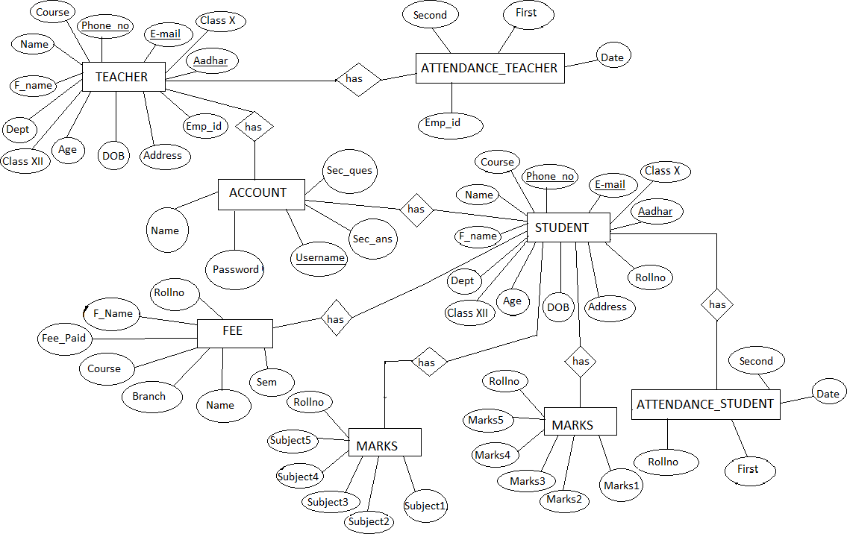
ER Diagram is a high-level conceptual data model diagram. Entity-Relation model is based on the notion of real-world entities and the relationship between them. ER modelling helps you to analyse data requirements systematically to produce a well-designed database.
- SCHEMA DIAGRAM:
A schema diagram is the skeleton structure that represents the logical view of the entire database. It contains a descriptive detail of the database.
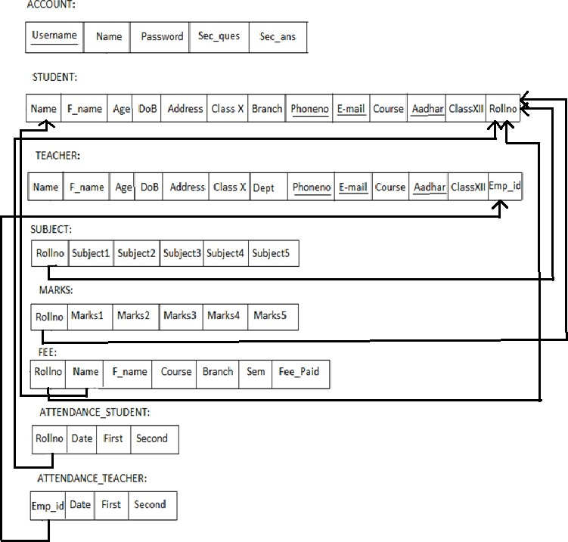

CHAPTER – 5
- TABLE DESCRIPTION:

- DATABASE DESIGN:

- ACCOUNT TABLE:
Account table consists of five attributes which are Username, Name, Password, Sec_ques, Sec_ans.Username is used as Primary key.
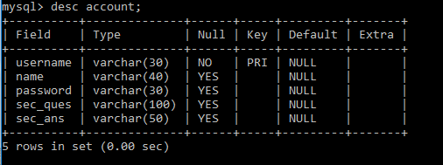
Desc account:

- STUDENT TABLE:
Student table is used to add the details of new student like Name,phoneno.,DoB,course,Branch etc...Phoneno. ,E-mail and Aadhar are used as Primary key.
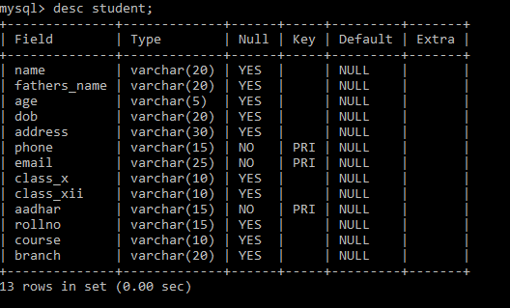
Desc student:

- TEACHER TABLE:
Teacher table is used to add the details of new student like Name, phoneno.,DoB, course,Branch etc...Phoneno. ,E-mail and Aadhar are used as Primary key.
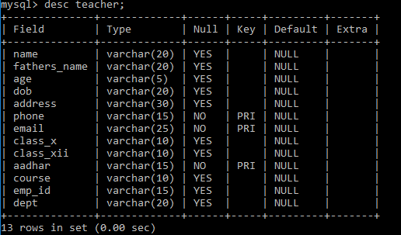
Desc teacher:

- ATTENDANCE_STUDENT TABLE:
Attendance_Student table is used to mark the attendance of the student day to day which as attributes like rollno,name,first and second half.
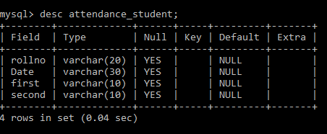
Desc attendance_student:

- ATTENDANCE_TEACHER TABLE:
Attendance_Teacher table is used to mark the attendance of the teacher day to day which as attributes like emp_id,name,first and second half.
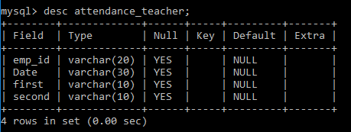
Desc attendance_teacher:

- SUBJECT TABLE:
Subject table is used to add the subjects of the student in that particular sem with the attributes like rollno and five subjects.
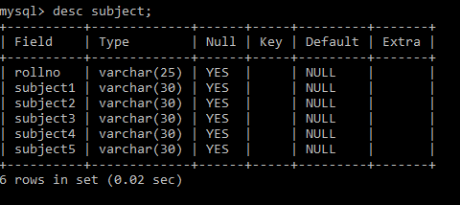
Desc Subject:

- MARKS TABLE:
Marks table is used to add the marks of the particular subjects of the student in a particular sem and the attributes used are rollno and five subject marks.
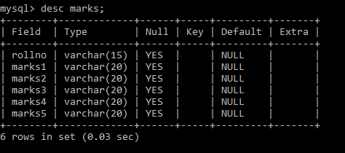
Desc Marks:

- FEE TABLE:
fee table is used to pay the fee dues of the student for that particular sem and the attributes used like rollno, name, fathersname, course, branch, sem and fee_paid.
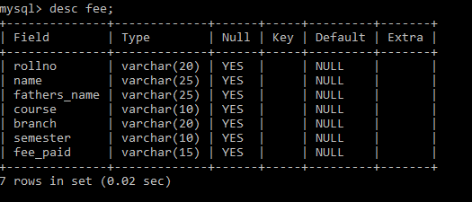
Desc Fee:

CHAPTER – 6
- TABLE WITH VALUES:

- OUTPUT DESIGN:

- ACCOUNT TABLE:
Account table consists of five attributes which will be retrived from user when the user signsup/logs in.
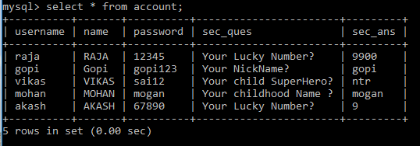
Select * from account:

- STUDENT TABLE:
Student table is used to add the details of new Student like Name, phoneno., DoB, course, Branch etc. Phoneno.E-mail
and Aadhar are used as Primary key.
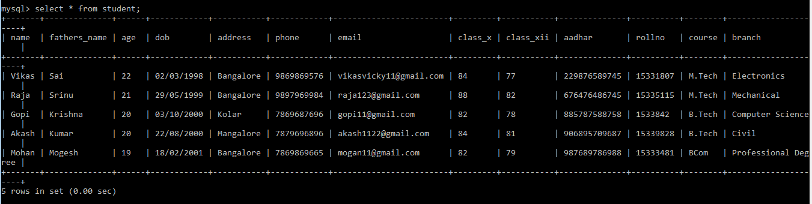
Select * from student:

- TEACHER TABLE:
Teacher table is used to add the details of new student like Name, phoneno., DoB, course, Branch etc. Phoneno., E-mail and Aadhar are used as Primary key.
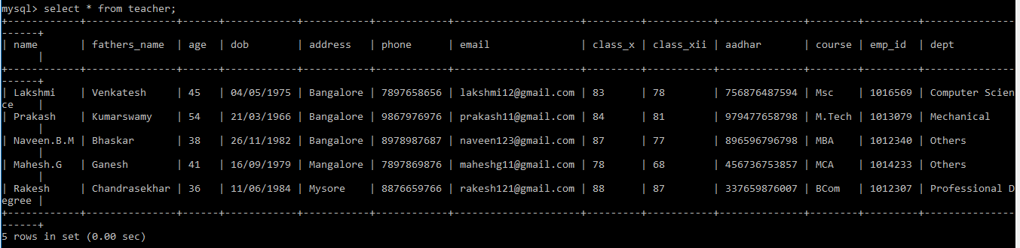
Select * from teacher:
- ATTENDANCE_STUDENT TABLE:
Attendance_Student table is used to mark the attendance of the student day to day which as attributes like rollno, name, first and second half.
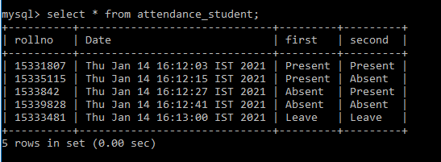
Select * from attendance_student:

- ATTENDANCE_TEACHER TABLE:
Attendance_Teachertable is used to mark the attendance of the teacher day to day which as attributes like emp_id,name, first and second half.
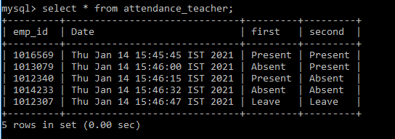
Select * fromattendance_teacher:

- SUBJECT TABLE:
Subject table is used to add thesubjects of the student in that particular sem with the attributes like rollno and five subjects.
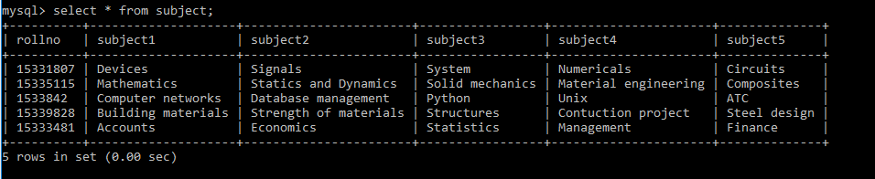
Select * from Subject:
- MARKS TABLE:
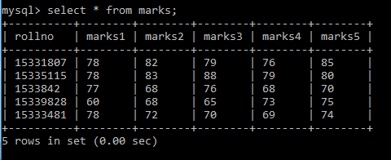
Markstable is used to add the marks of the particular subjects of the student in a particular sem and the attributes used are rollno and five subject marks. Select * from Marks:
- FEE TABLE:
fee table is used to pay the fee dues of the student for that particular sem and the attributes used like rollno, name, fathersname, course, branch, sem and fee_paid.
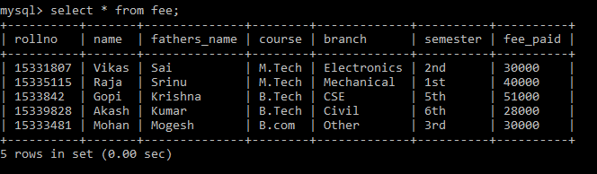
Select * from Fee:

CHAPTER – 7
- IMPLEMENTATION:

- SAMPLE CODE:
Package institution.management.system;
importjava.awt.*;
importjavax.swing.*;
importjava.awt.event.*;
importjava.sql.*;
importinstitution.management.system.Signup;

public class Login extends JFrame implements ActionListener{
privateJPanel panel;
privateJTextFieldtextField;
privateJPasswordFieldpasswordField;
privateJButton b1,b2,b3;
public Login() {
setBackground(new Color(169, 169, 169));
setBounds(600, 300, 600, 400);
panel = new JPanel();
panel.setBackground(new Color(176, 224, 230));
setContentPane(panel);
panel.setLayout(null);
JLabel l1 = new JLabel("Username : ");
l1.setBounds(124, 89, 95, 24);
panel.add(l1);
JLabel l2 = new JLabel("Password : ");
l2.setBounds(124, 124, 95, 24); panel.add(l2);
textField = new JTextField();
textField.setBounds(210, 93, 157, 20);
panel.add(textField);
passwordField = new JPasswordField();
passwordField.setBounds(210, 128, 157, 20);
panel.add(passwordField);
JLabel l3 = new JLabel("");
l3.setBounds(377, 79, 46, 34);
panel.add(l3);
JLabel l4 = new JLabel("");
l4.setBounds(377, 124, 46, 34);
panel.add(l3);
b1 = new JButton("Login");
b1.addActionListener(this);
b1.setForeground(new Color(46, 139, 87));
b1.setBackground(new Color(250, 250, 210));
b1.setBounds(149, 181, 113, 39);
panel.add(b1);
b2 = new JButton("SignUp");
b2.addActionListener(this);
b2.setForeground(new Color(139, 69, 19));
b2.setBackground(new Color(255, 235, 205));
b2.setBounds(289, 181, 113, 39);
panel.add(b2);
b3 = new JButton("Forgot Password");
b3.addActionListener(this);
b3.setForeground(new Color(205, 92, 92));
b3.setBackground(new Color(253, 245, 230));
b3.setBounds(199, 231, 179, 39);
panel.add(b3);
JLabel l5 = new JLabel("Trouble in Login?");
l5.setFont(new Font("Tahoma", Font.PLAIN, 15));
l5.setForeground(new Color(255, 0, 0));
l5.setBounds(70, 240, 130, 20);
panel.add(l5);
JPanel panel2 = new JPanel();
panel2.setBackground(new Color(176, 224, 230));
panel2.setBounds(24, 40, 434, 263);
panel.add(panel2)
}
public void actionPerformed(ActionEventae){
if(ae.getSource() == b1){
Boolean status = false;
try {
conn con = new conn();
String sql = "select * from account where username=? and password=?";
PreparedStatementst = con.c.prepareStatement(sql);
st.setString(1, textField.getText());
st.setString(2, passwordField.getText());
ResultSetrs = st.executeQuery();
if (rs.next()) { this.setVisible(false);
new Loading().setVisible(true);
} else
JOptionPane.showMessageDialog(null, "Invalid Login...!.");
} catch (Exception e2) {
e2.printStackTrace();} }
if(ae.getSource() == b2){
setVisible(false);
Signup su = new Signup();
su.setVisible(true);}
if(ae.getSource() == b3){
setVisible(false);
ForgotPassword forgot = new ForgotPassword();
forgot.setVisible(true);}
}
public static void main(String[] args) {
new Login().setVisible(true); } }

CHAPTER – 8
- TESTING:
System testing is the stage of implementation, which is aimed at ensuring that the system works accurately and efficiently before live operation commences. Testing is the process of executing the program with the intent of finding errors and missing operations and also a complete verification to determine whether the objectives are met and the user requirements are satisfied. The ultimate aim is quality assurance.
- UNIT TESTING:
The software units in a system are modules and routines that are assembled and integrated to perform a specific function. Unit testing focuses first on modules, independently of one another, to locate errors. This enables, to detect errors in coding and logic that are contained within each module. This testing includes entering data and ascertaining if the value matches to the type and size supported by java. The various controls are tested to ensure that each performs its action as required.
- INTEGRATION TESTING:
Data can be lost across any interface, one module can have an adverse effect on another, sub functions when combined, may not produce the desired major functions. Integration testing is a systematic testing to discover errors associated within the interface. The objective is to take unit tested modules and build a program structure. All the modules are combined and tested as a whole. Here the Server module and Client module options are integrated and tested. This testing provides the assurance that the application is well integrated functional unit with smooth transition of data.
- USER ACCEPTANCE:
Testing User acceptance of a system is the key factor for the success of any system. The system under consideration is tested for user acceptance by constantly keeping in touch with the system users at time of developing and making changes whenever required.

CHAPTER – 9
- SCREENSHOT:

- LOGIN FORM:
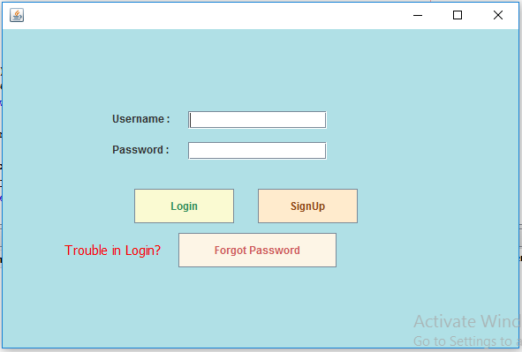
This page represents the first thing about our website. It leads on to the login point for its personnel; it takes up the username, password and signup.

- SIGNUP PAGE:
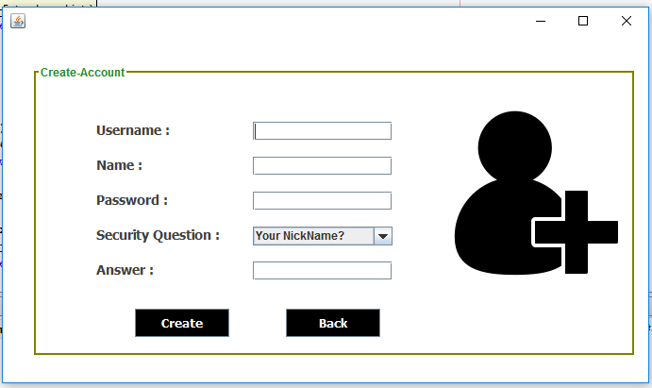
This page represents signing up to website. It leads to registering to website making username and password, it takes the up username, name, password and security question. This information is mandatory.

- HOME PAGE USER:
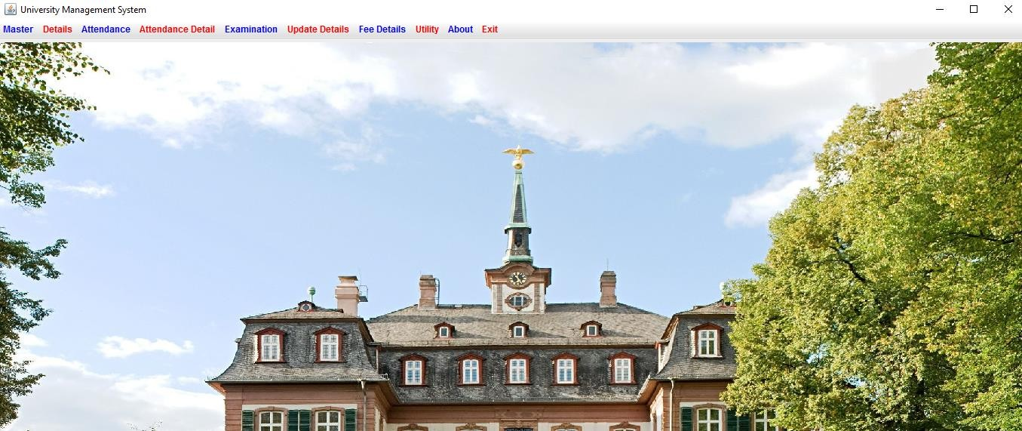
This page shows us what user can see and access. He can add, remove,update and upload the data. He can logout from the website in homepage.
- STUDENT FORM:
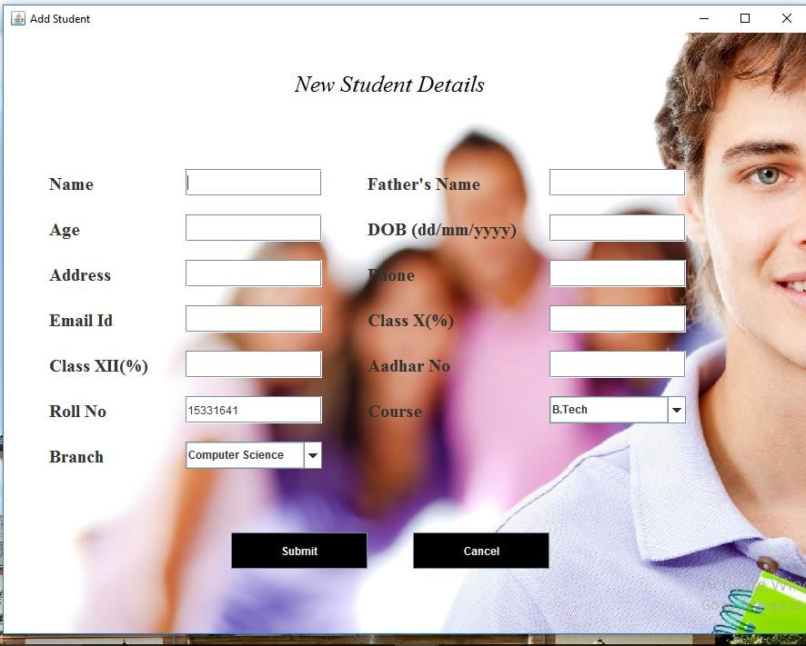
In this we can add the new student details which will be stored in back end of user. This details further can updated in the update page.

- TEACHER FORM:
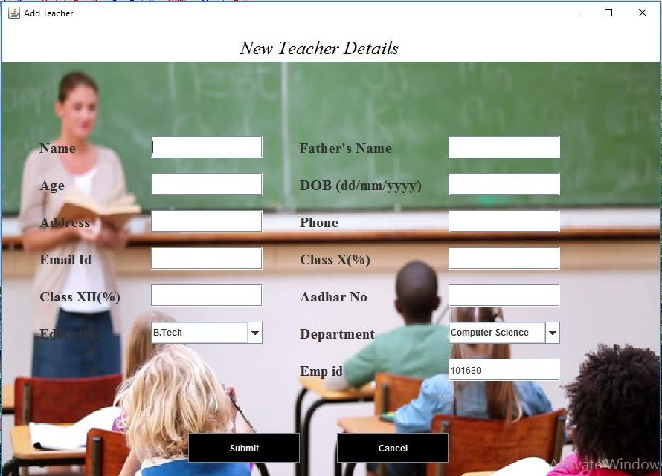
In this we can add the new teacher details which will be stored in back end of user.This details further can updated in the update page.
- MARKS AND SUBJECT PAGE:
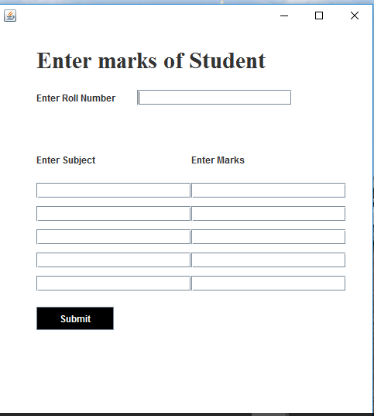
In this page we can enter the subjects and marks scored in that particular subject along the rollno.

- FEE PAYMENT PAGE:
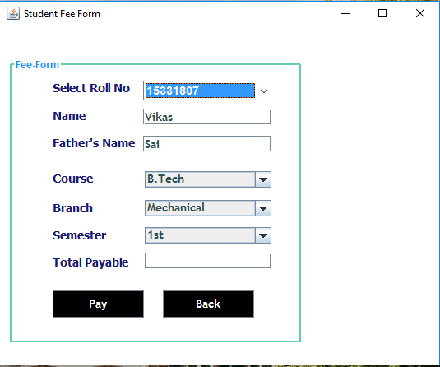
In this page we can the pay the fee dues of the particular student which uses rollno,course,branch and sem to pay the fee.

CHAPTER – 10
- CONCLUSION:
The project entitled as Institution Management System is the system that deals with the issues related to a particular institution.
This project is successfully implemented with all the features mentioned in system requirements specification.
The application provides appropriate information to users according to the chosen service.
The project is designed keeping in view the day-to-day problems faced by a college.
Deployment of our application will certainly help the college to reduce unnecessary wastage of time in personally going to each department for some information.
Awareness and right information about any college is essential for both the development of student as well as faculty. So, this serves the right purpose in achieving the desired requirements of both the communities.

CHAPTER – 11
- REFERENCES:

- BOOKS AND WEBSITES:

- Internet & World Wide Web: How to Program Deitel, PJ Deitel.
- Code for Interview YouTube Channel.
- Database System Concepts, by Silberschatz, Sudarshan, and Korth.
- Fundamentals of Database Systems, Ramez Elmasri and Shamkant B. Navathe, 7th Edition. 2017, Pearson...

